TERRAFORM FINAL TASK
Write a code using Terraform that deploys and achieves the following:-
Create an EC2 Instance on AWS Cloud using the below-mentioned ubuntu AMI and instance_type. Or, (You can use of your choice as well) ami = "ami-0461b1436c9b3c1a3" instance_type = "t2.micro"
Install a web server on the same EC2 Instance. The web server should listen on port 8080.
- Create a Docker-compose file for the project: https://github.com/betawins/cricbuzz-docker-hello-world.git and point it to port 8000.
- Make the web server point to the above service so that 8080 returns the response from the Docker service.
- Configure to Save the Logs in the location /var/log/cb.log
- Write the Log rotate configuration for the above file

- Open VS Code and go to main.tf
- Configure AWS provider:
- Set region to eu-north-1
- Create Key Pair using your local public key:
- Resource: aws_key_pair
- Key path: ~/.ssh/id_rsa.pub
- Create a Security Group named cb-sg
- Add Ingress rules:
- SSH 22
- Nginx Reverse Proxy Port 8080
- Docker App Port 8000
- Allow traffic from:
- 0.0.0.0/0

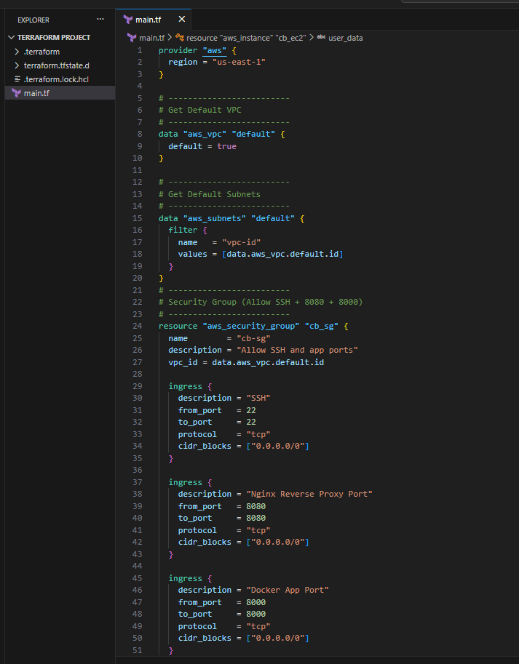
- ontinue inside aws_security_group resource
- Add Egress rule:
- Allow all outbound traffic (protocol = "-1")
- CIDR: 0.0.0.0/0
- Start creating the EC2 instance resource:
- Resource: aws_instance "cb_ec2"
- Define values:
- AMI ID
- Instance type (shown: t3.small)
- Attach key pair: aws_key_pair.cb_key.key_name
Attach security group: aws_security_group.cb_sg.id
- Add user_data script inside EC2 resource
- Script performs:
  - Install required packages:
    - docker, docker-compose, nginx, git, logrotate
- Clone GitHub project:
  - https://github.com/betawins/cricbuzz-docker-hello-world.git
- Go inside project folder
- Create docker-compose.yml file with:
  - Service using nginx:alpine
  - Port mapping:
    - 8000:80
- Start container:
  - docker-compose up -d
- Configure Nginx reverse proxy:
  - Listen on 8080
  - Proxy pass to 127.0.0.1:8000
- Restart nginx:
  - systemctl restart nginx

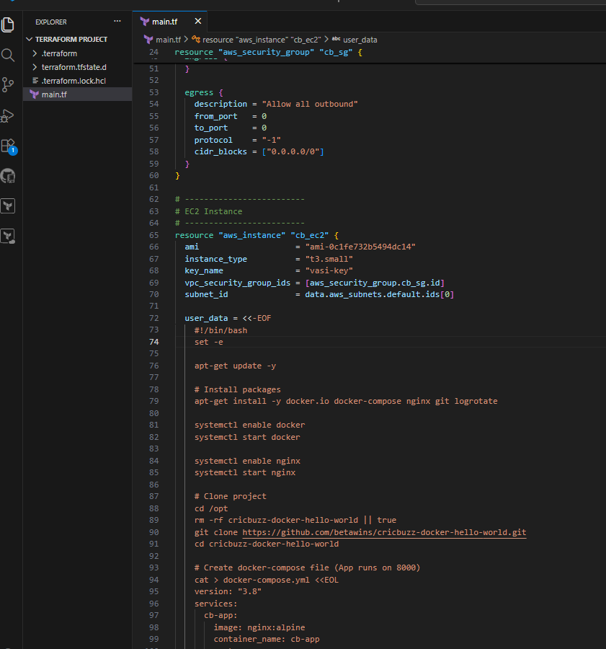
- In user_data, create Logrotate config file:
- Path: /etc/logrotate.d/cb-log
- Configure log rotation for:
- /var/log/cb.log
- Settings included:
- daily rotate
- keep 7 files
- compress
- create permissions
- reload nginx after rotate
- Add EC2 tagging:
- Name = cb-ec2
- Add output block:
- Output EC2 public IP

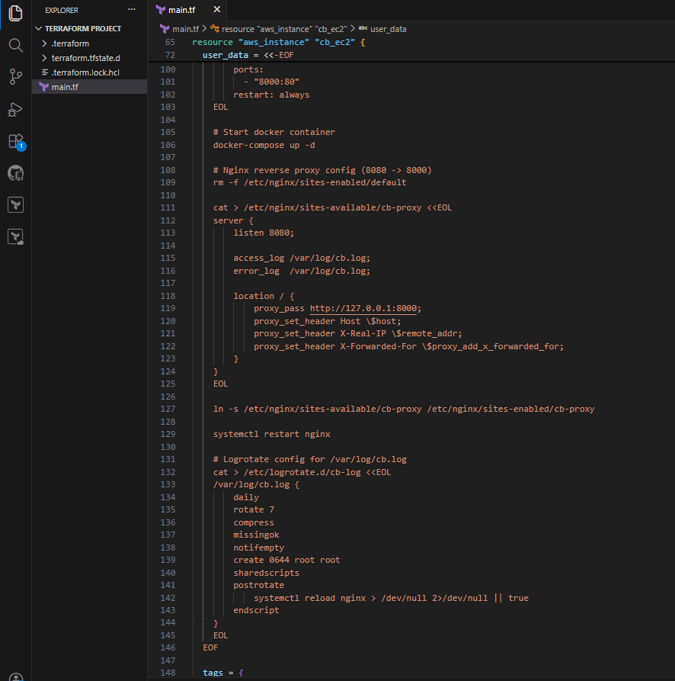

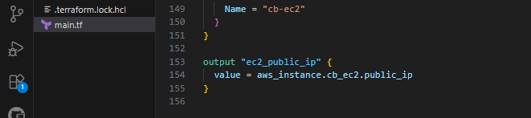
- Open VS Code Terminal (PowerShell)
- Run Terraform initialization:
- terraform init
- Verify output:
- Provider plugins downloaded
- Terraform initialized successfully
- Run apply command:
- terraform apply -auto-approve
- Terraform creates resources:
- Security group
- Key pair
- EC2 instance
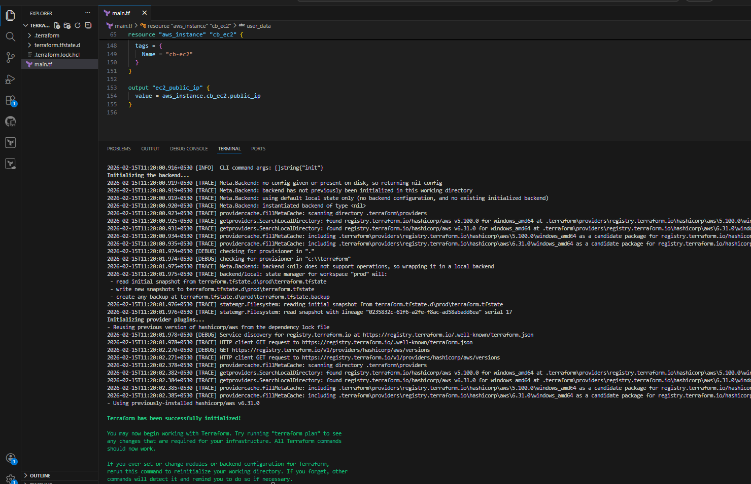
- Wait until EC2 creation finishes
- Confirm success message:
- “Apply complete!”
- Terraform prints output:
- Public IP shown (example from image):
- ec2_public_ip = "51.20.93.220"
- Use the IP to test your app:
- Open browser:
- http://51.20.93.220:8080

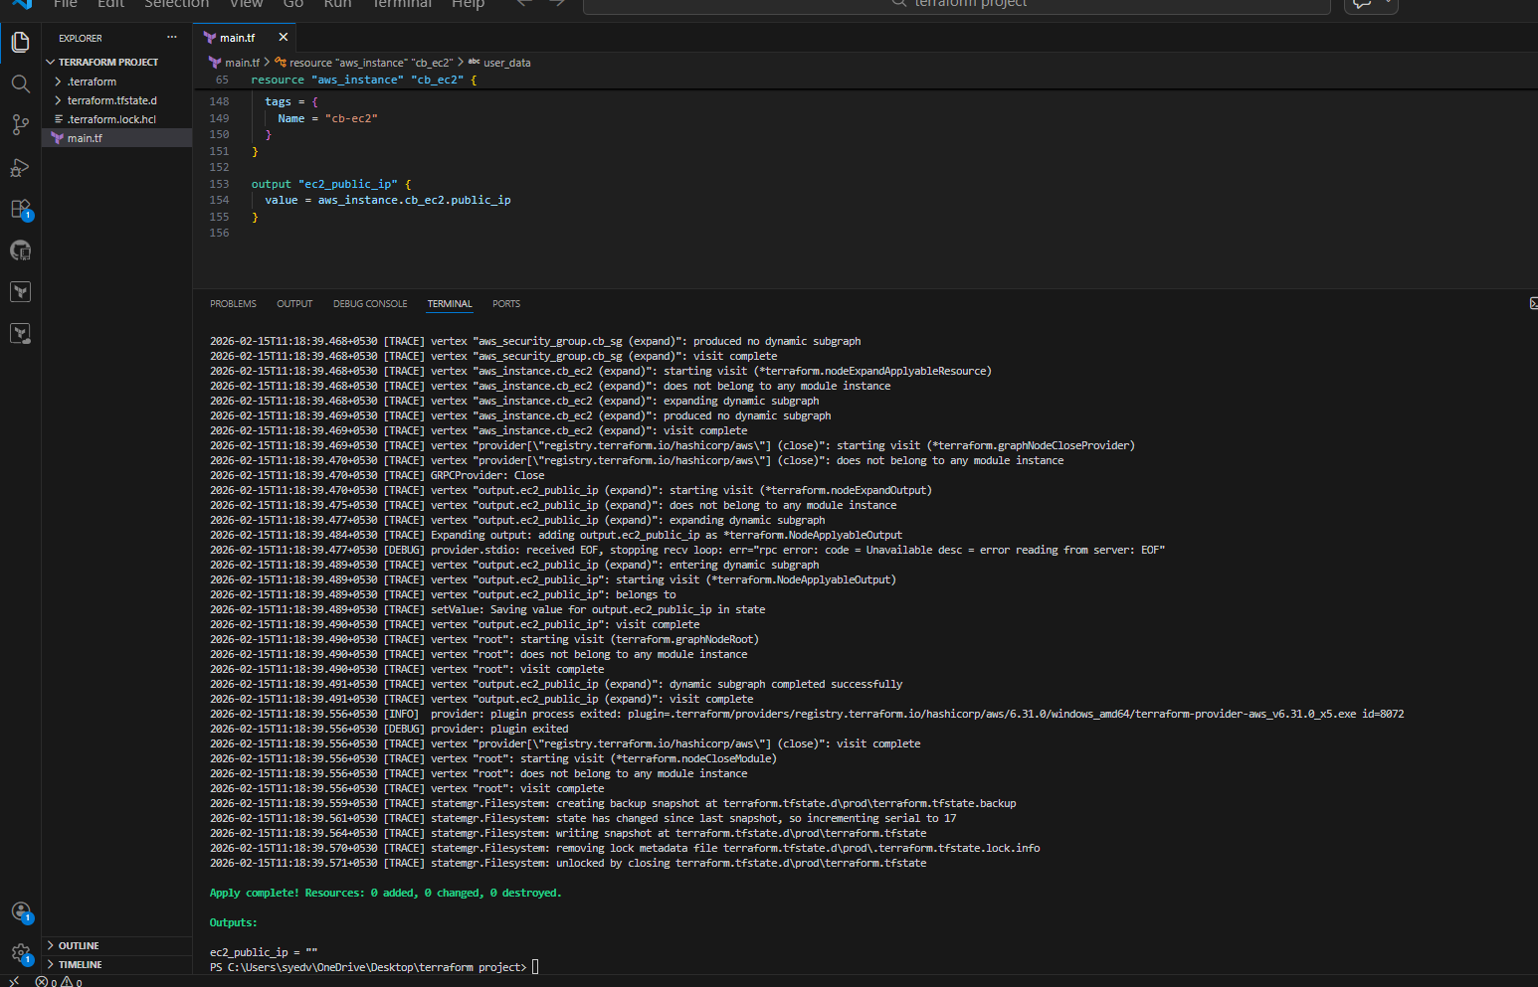

- Open browser
- Enter EC2 public IP with port 8080:
- http:// 54 266 80 221:8080
- If you see Welcome to nginx!
It confirms Nginx is working on port 8080
Steps:
- Open browser
- Enter EC2 public IP with port 8000:
- http:// 54.266.80 221:8000
- If you see Welcome to nginx!
It confirms Docker container service is running on port 8000

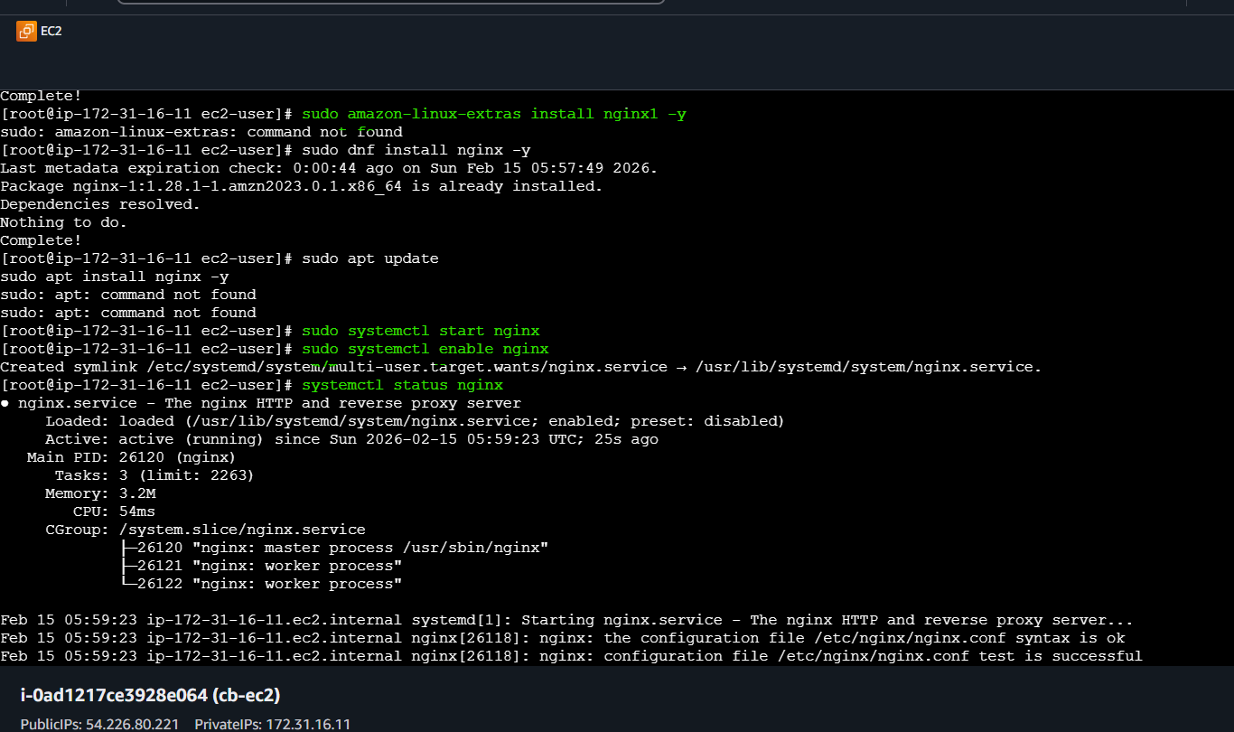

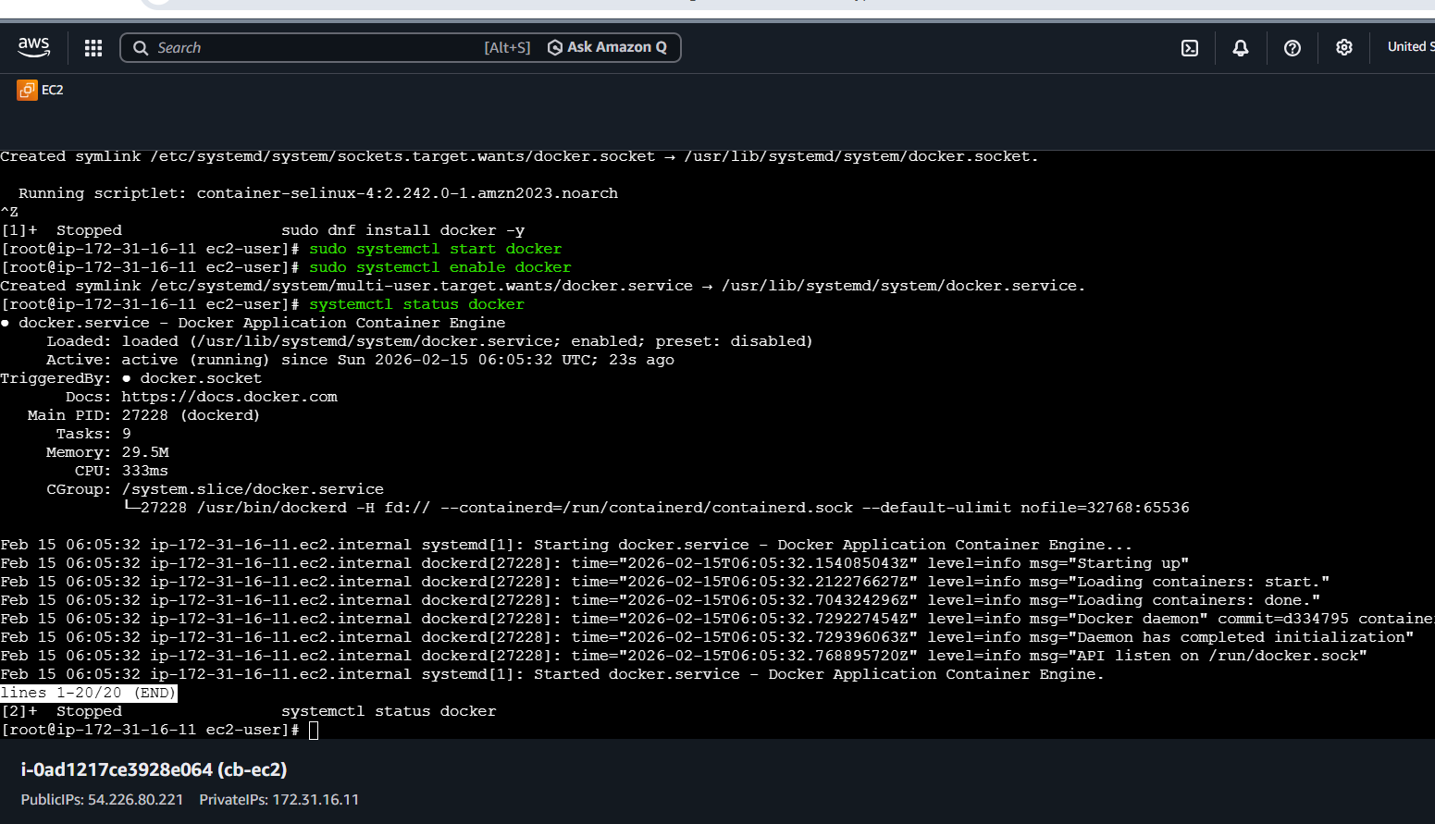
Check Logs Saved in /var/log/cb.log
Steps:
- Login to EC2 using SSH
- Switch to root user:
- sudo -i
- View the log file:
- cat /var/log/cb.log
- Confirm the logs are getting written (example from image):
  - GET / HTTP/1.1 200
  - GET /favicon.ico 404
This verifies Nginx access logs are successfully stored in /var/log/cb.log

